Continue Setup

Today I will be showing you how to add Tmux, emacs, and Fail2Ban onto CentOS and Ubuntu servers. I will also be adding in cowsay and lolcat, just for fun.

CentOS: tmux

(tmux is a terminal multiplexer which allows you to manage windows within your terminal.)

Firstly, I will install Tmux onto my CentOS server. To start, I will first need to use sudo yum install. In CentOS to install repositories, we use yum instead of the usual apt-get. Yum stands for Yellowdog Updater, this allows for package installation and management on CentOS. After tying the command I provided below, you should see that the package has been successfully downloaded and installed successfully.

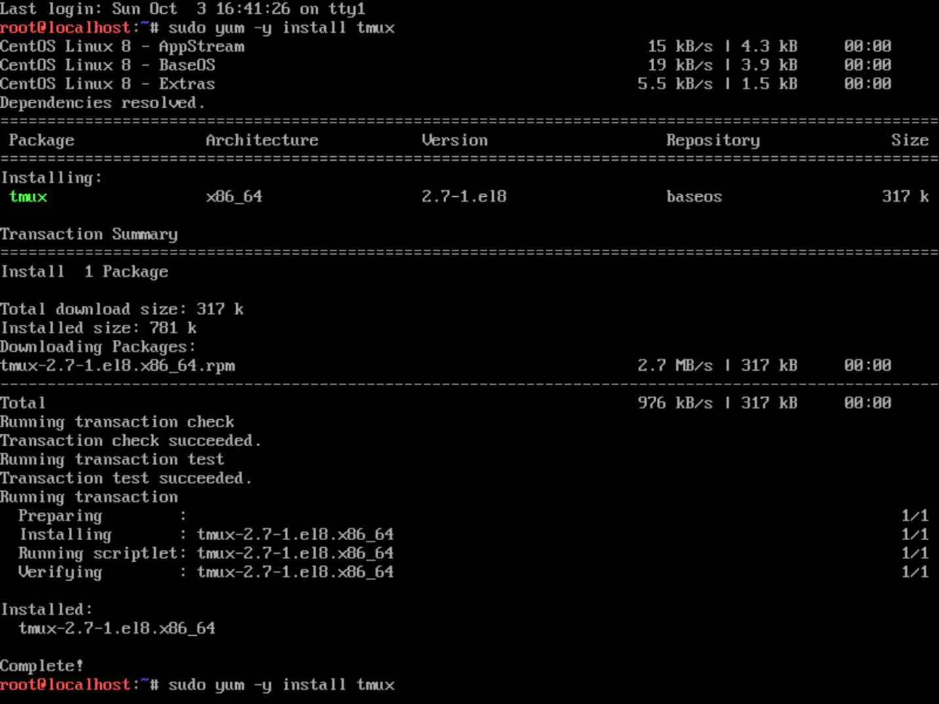Commands used: sudo yum -y install tmux

Ubuntu Server: tmux

(tmux is a terminal multiplexer which allows you to manage windows within your terminal.)

Next I will install tmux on my Ubuntu server. First we will update our package lists from the internet, to do this we will run the command sudo apt-get update. After typing in your administrator password, you will see that your packages have been updated successfully.

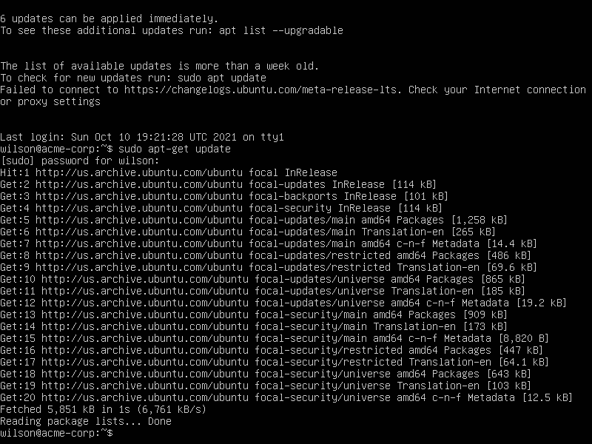Commands used: sudo apt-get update

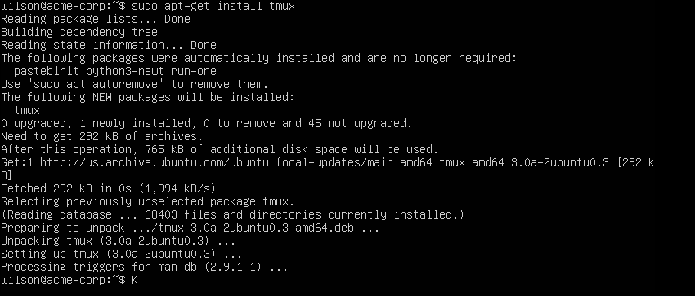Next we will install tmux by using the command sudo apt-get install tmux. This will fetch and install the tmux packages. Commands used: sudo apt-get install tmux

CentOS: emacs

(emacs is a customizable text editor which allows a constant availability of basic editing commands no matter what you’re doing.)

Now that tmux is successfully installed on both servers, we can move on to emacs. Similarly to how we used yum to install tmux, we can also use it to get emacs. Use the command I provided below to start the install for emacs. After running this command you should see the packages for emacs begin to install. About mid-way through the installation, you will be prompted if you would like to continue the installation. Type “y” to continue and finish the emac installation.

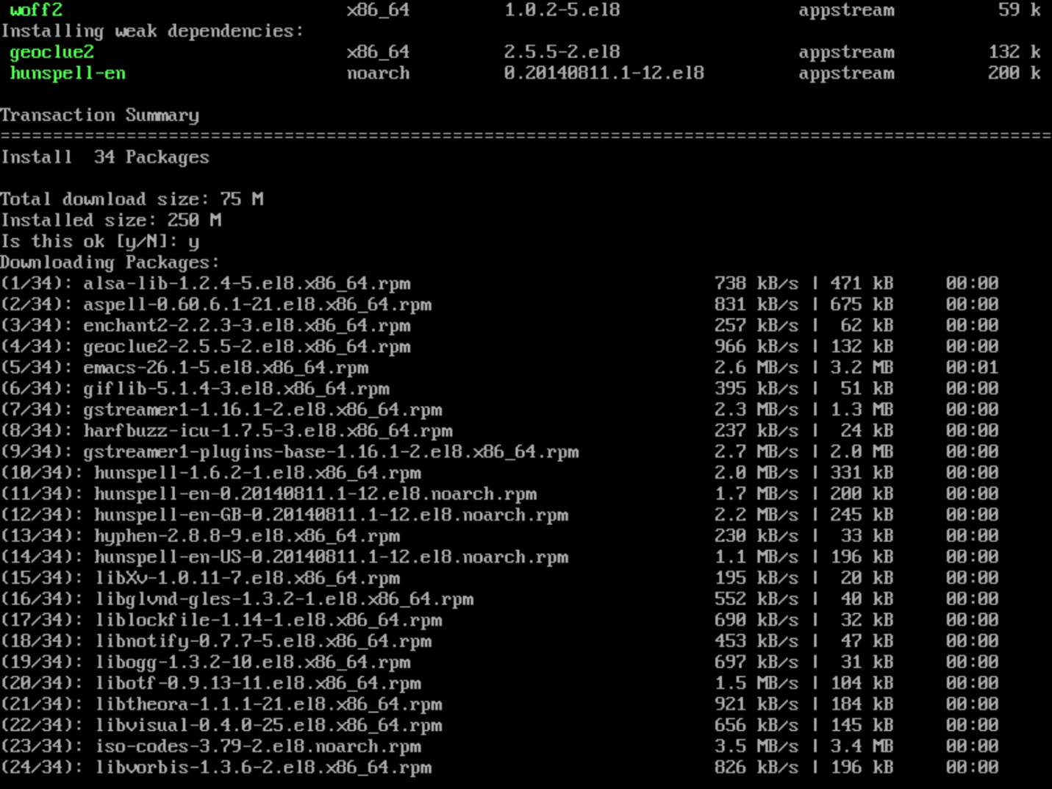Commands used: sudo yum install emacs

Ubuntu Server: emacs

(emacs is a customizable text editor which allows a constant availability of basic editing commands no matter what you’re doing.)

Now to install emacs on the Ubuntu server. To do this we will use the command sudo apt get install emacs. After running this command you should see a prompt asking you to type y or n to continue. Type “y”. After this the installation will finish.

Commands used: sudo apt-get install emacs

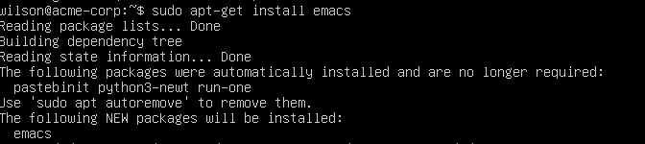

To confirm emacs is installed correctly, type the command emacs –version to show the version installed.

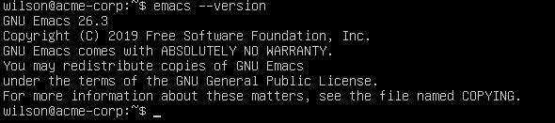

CentOS: Fail2Ban

(Fail2Ban is a service which monitors logfiles in order to prevent malicious brute force attacks on a server.)

Moving on, I will now install Fail2Ban onto my CentOS server. First I need to acquire EPEL, extra packages for enterprise Linux, as a prerequisite to get Fail2Ban working correctly. To install EPEL, run the command sudo yum install epel-release. You will be prompted if you would like to install the package epel-release. Type “y” to continue the install.

Commands used: sudo yum install epel-release

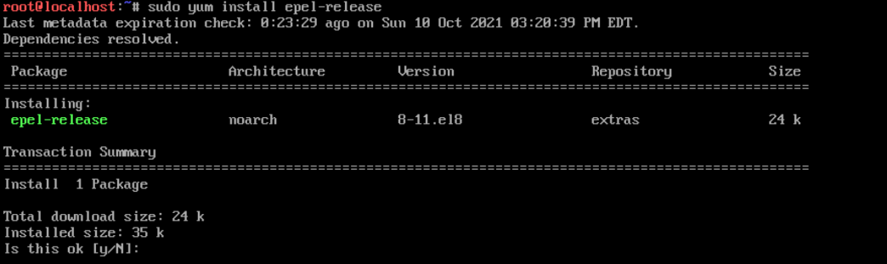

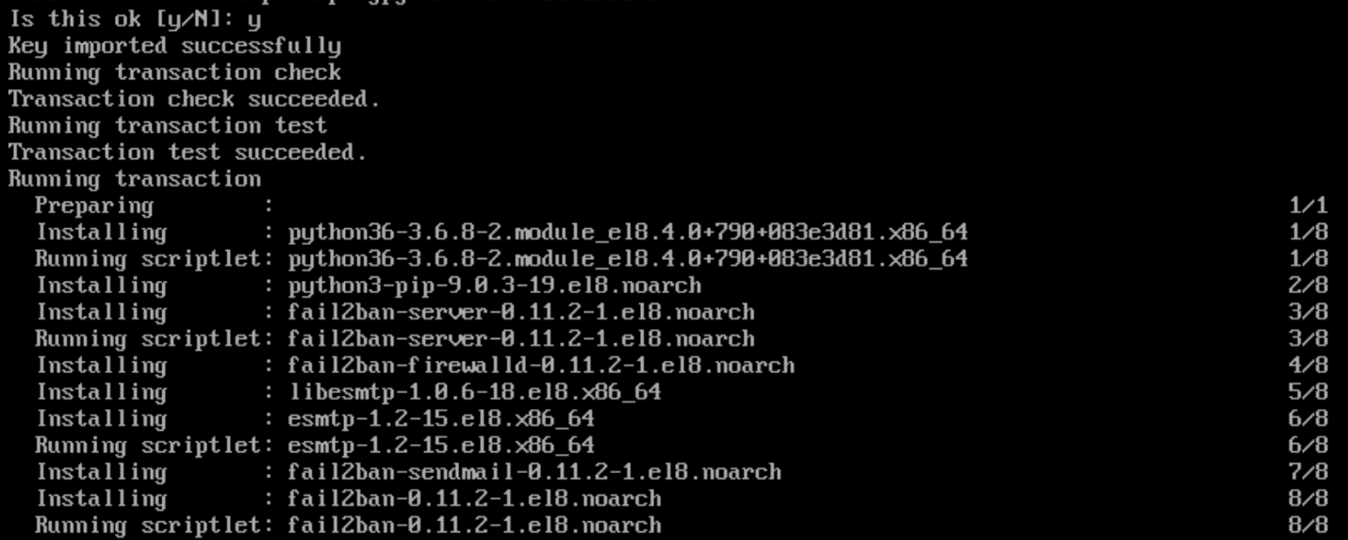

After installing the prerequisite EPEL package, we can now to install Fail2Ban. To start the install type sudo yum install fail2ban. After using this command you should see that there is prompt if you would like to install fail2ban and its dependences. Type “y” to begin the install. After this you should see another prompt before the installation finishes. Press “y” again. After the second prompt, you should see that fail2ban has successfully been installed.

Commands used: sudo yum install fail2ban

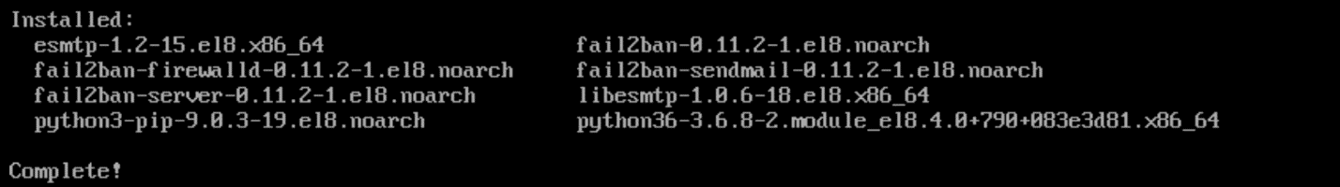

Ubuntu Server: Fail2Ban

(Fail2Ban is a service which monitors logfiles in order to prevent malicious brute force attacks on a server.)

To install fail2ban on the Ubuntu server, we will simply run the command sudo apt install fail2ban. After running this command, you should see a prompt asking if you would like to continue. Type “y” and press enter. The installation is now complete and fail2ban is installed on the Ubuntu server.

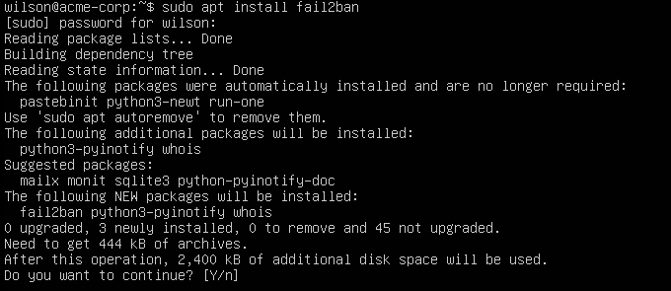Commands used: sudo apt install fail2ban

CentOS: Cowsay

(Cowsay is a program which can generate ASCII pictures of a cow or other animals along with a message.)

I will now display how to install cowsay on CentOS, a fun program which generates a ASCII cow along with a message. To install the program run the provided command. After running the command you will be prompted to begin the installation. Type “y” and the installation will continue. You should see “Complete!” when the installation has finished.

Commands used: sudo yum install cowsay

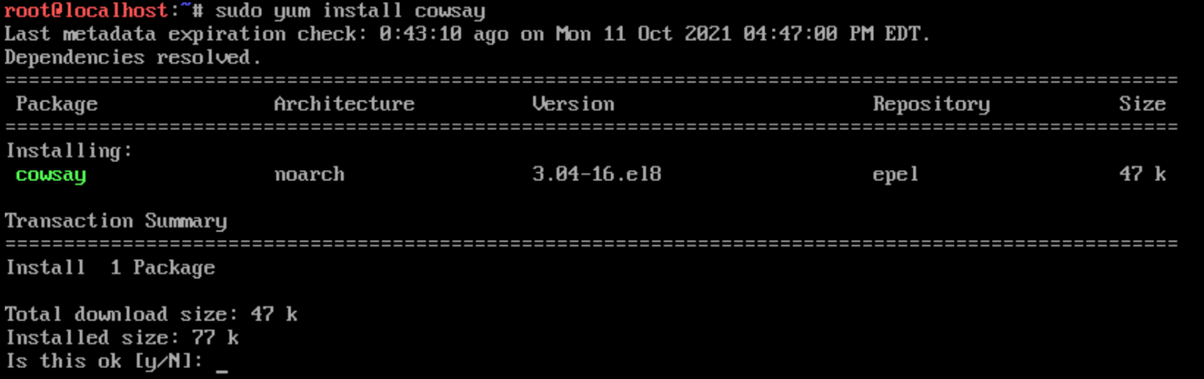

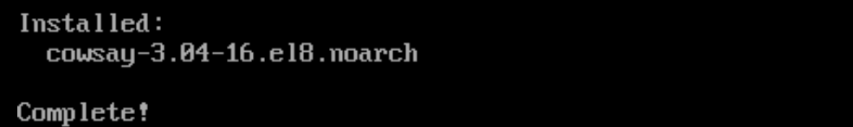

Ubuntu Server: Cowsay

(Cowsay is a program which can generate ASCII pictures of a cow or other animals along with a message.)

To install cowsay on Ubuntu, run the command sudo apt-get install cowsay. After running the command, cowsay will be successfully installed.

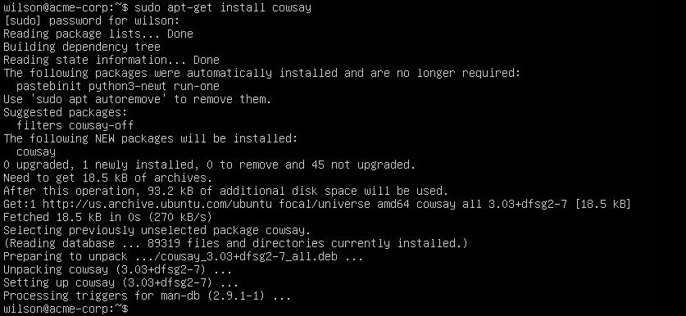Commands used: apt-get install cowsay

CentOS: lolcat

(Lolcat is a Linux utility similar to the cat command however it adds an assortment of rainbow colors within the terminal.)

To install lolcat on CentOS we first need to install the package ruby. Since lolcat is a part of ruby, it is required for this installation. First run the command yum install ruby. After running this command you will be prompted if you would like to continue the installation. Type “y” and hit enter to continue. After this, you should see that Ruby installation has been completed.

Commands used:

yum install ruby

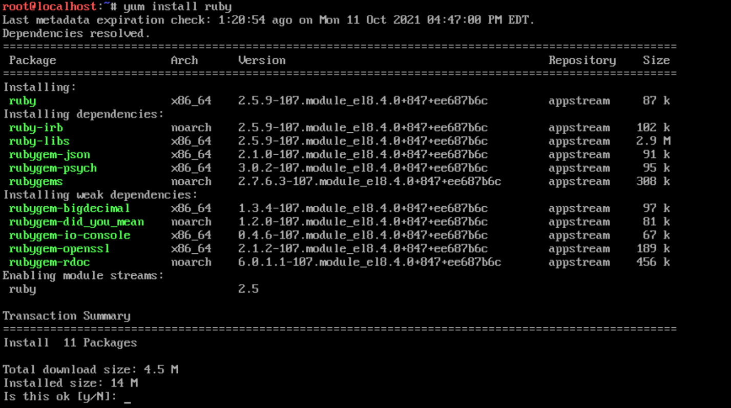

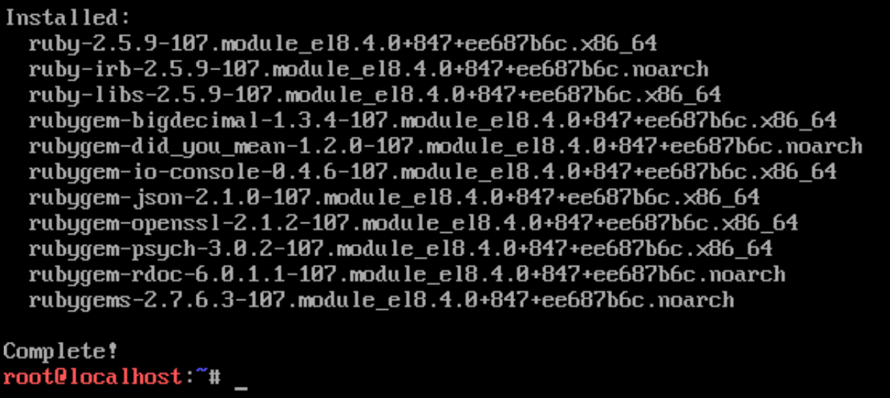

Now that we have ruby, we can start downloading the most recent version of lolcat from its repository. Run the wget command I have provided below to retrieve the zip file containing the lolcat files.

Commands used:

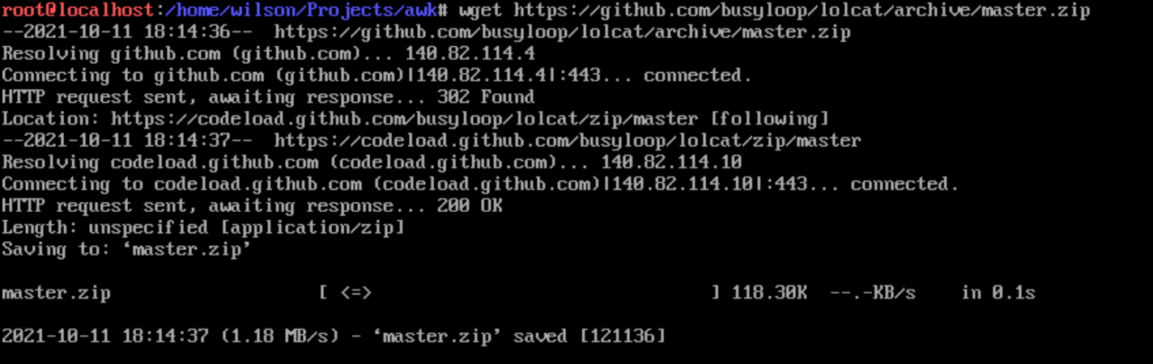wget <https://github.com/busyloop/lolcat/archive/master.zip>

Now that you have acquired the files, we need to unzip them. You will need to run the command unzip master.zip, which will them unzip the files into a folder called lolcat-master.

Commands used: unzip master.zip

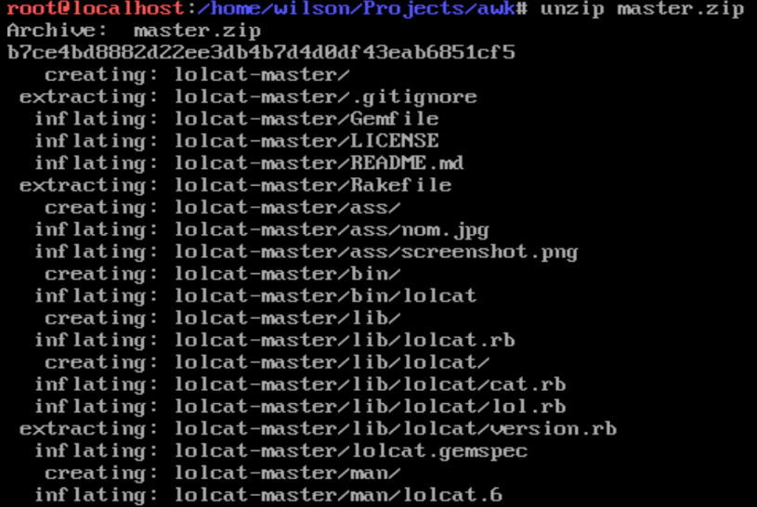

Finally, you will need to change the directory to lolcat-master/bin and then run the command gem install lolcat. This will install lolcat using gem, using the files you have downloaded.

Commands used:

cd lolcat-master/bin

gem install lolcat

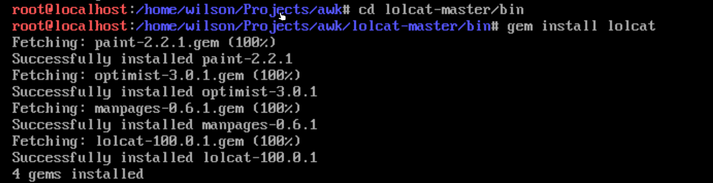

Confirm that lolcat is installed using the command provided.

Commands used: lolcat --version

Ubuntu: lolcat

(Lolcat is a Linux utility similar to the cat command however it adds an assortment of rainbow colors within the terminal.)

To install lolcat onto the Ubuntu server run the command I have provided below. This will install lolcat with all dependencies using the -y flag.

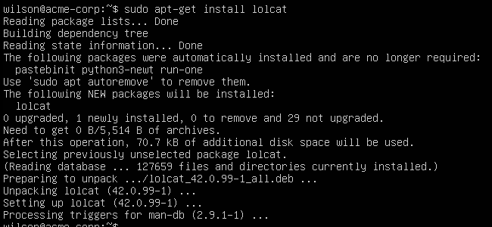Commands used: sudo apt-get install -y lolcat

Where are repositories kept in CentOS?

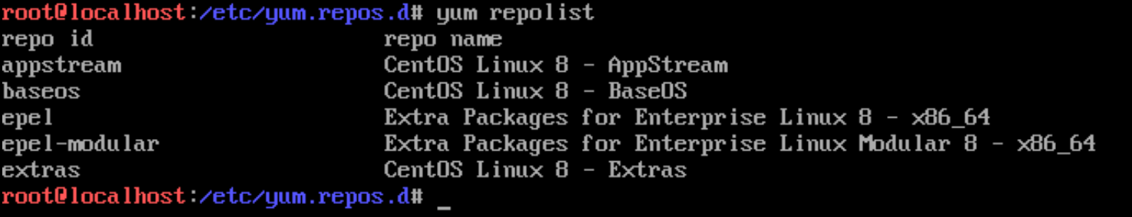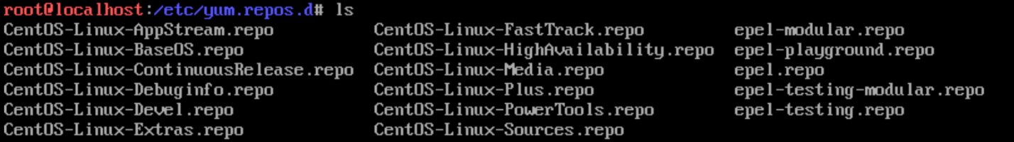In CentOS repositories are kept within the folder /etc/yum.repos.d. Use the ls command to view the contents of the folder.

You can also use the command yum repolist to list the current repos installed. You can also use the command yum repolist all to view all of the installed repos, even the disabled ones.

Commands used: yum repolist

By using the command dnf repository-packages epel list, you can see all packages listed under epel. This will return a very large list of packages.

Commands used: dnf repository-packages epel list

To install a repo from the EPEL list used the command dnf –enablerepo=”epel” install “package name”

To disable a repo on CentOS 8 use the command yum --disablerepo=reponame. To enable a repo use the command yum --enablerepo=reponame

How to add PPA

sudo add-apt-repository <PPA_info> This command adds the PPA repository to the list.

sudo apt-get update This command updates the list of the packages that can be installed on the system.

sudo apt-get install <package_in_PPA> This command installs the package.

Adding repositories and enabling them in Centos

yum-config-manager --add-repo repository_url

yum-config-manager --enable repository

Where are repositories kept in Ubuntu?

On the Ubuntu server, repositories are kept in the folder /etc/apt under the file sources.list. To view the sources.list file, cat the file or open it within an editor.



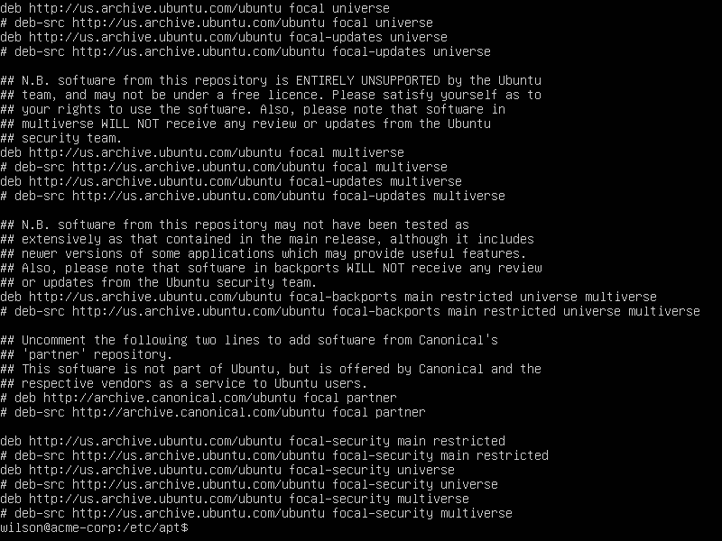

How do you install vim on CentOS?

(Vim is a text editor similar to vi except it is much more rich in features and contains various improvements.)

To install vim on CentOS 8 use the yum command I have provided below. This will install vim and its required dependencies. You should see “Complete!” when the installation finishes.

Commands usedL: sudo yum install vim-enhanced -y

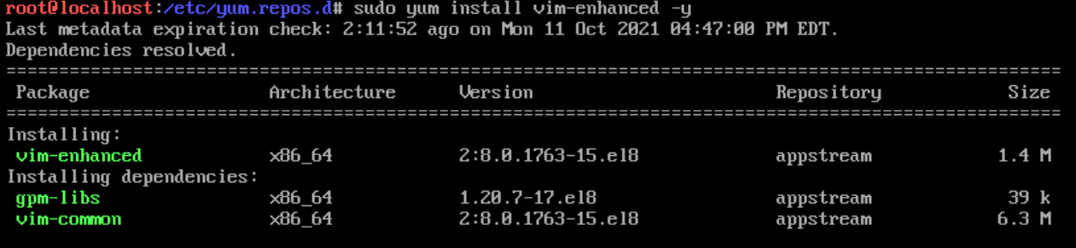

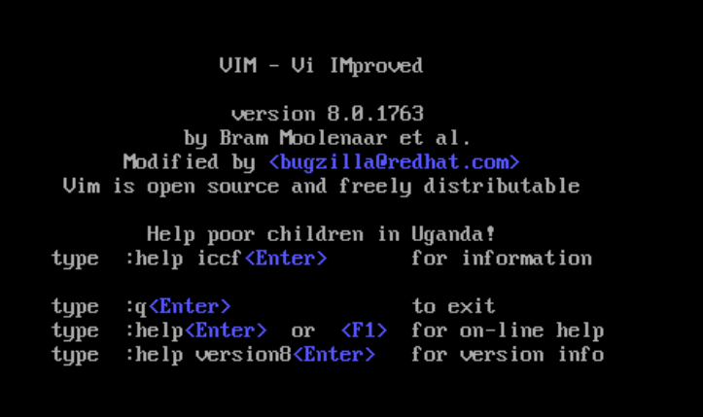To confirm that Vim has been properly installed run the command vim. You should see that it lists VIM – Vi IMproved

How do you install vim on Ubuntu?

To install vim onto Ubuntu, run the command sudo apt-get install vim. After running this you will be prompted whether you would like to continue the installation. Type “y” and press enter to continue.

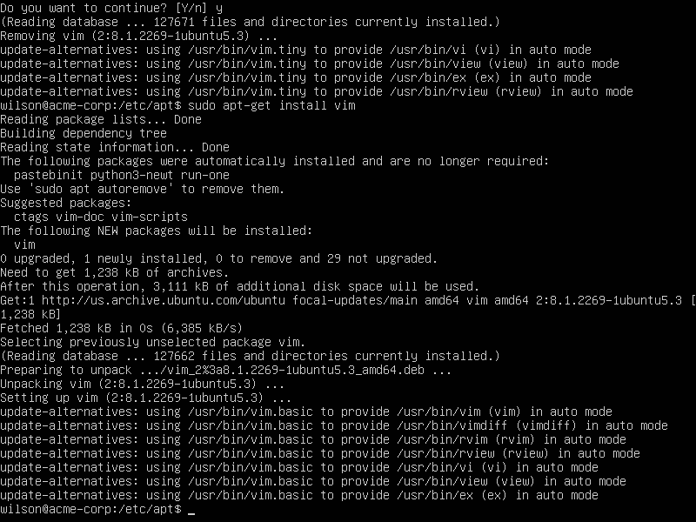Commands used: sudo apt-get install vim

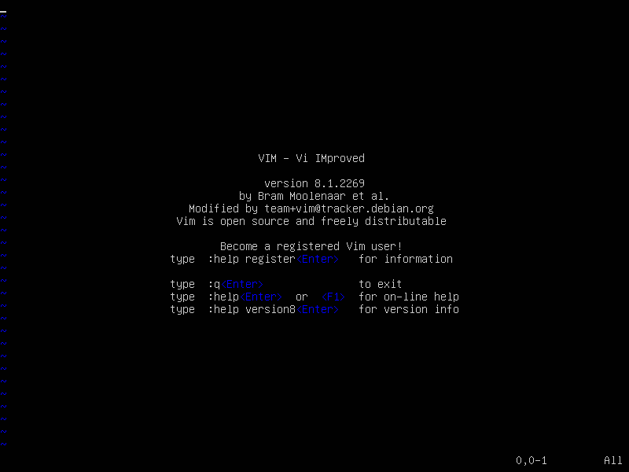To check if vim has been properly installed use the command vim. You should see that it lists VIM – Vi IMproved .

Overview: CentOS installation

Tmux

Emacs

Fail2ban – prerequisites: epel-release, master.zip

Cowsay

Lolcat -- prerequisites: ruby

vim-enhanced

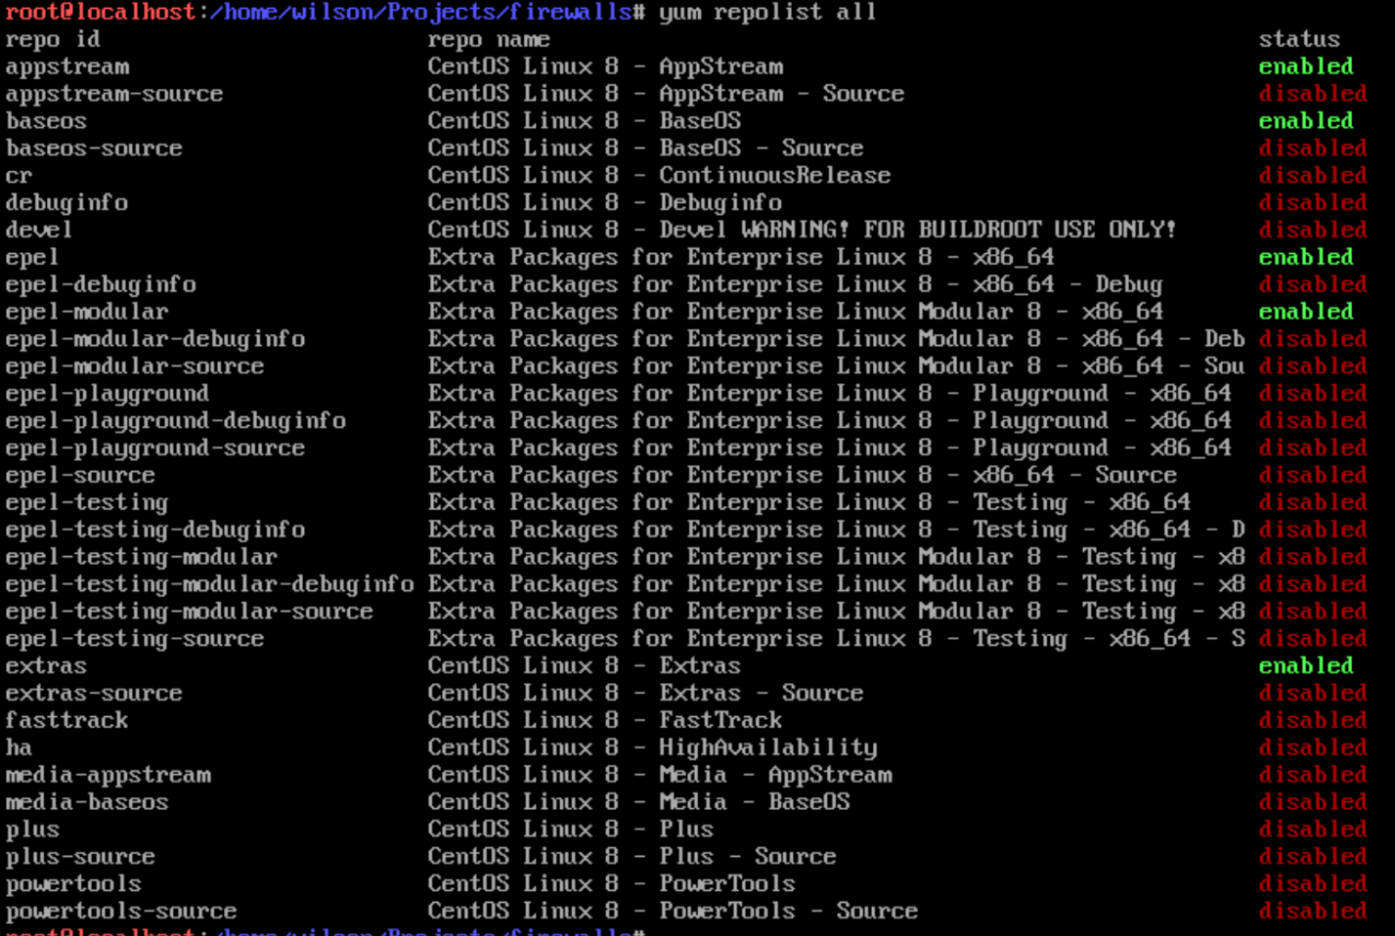By using the command yum repolist all, I can view all repos installed, even if they’re currently disabled

Overview: Ubuntu installation

Tmux

Emacs

Fail2ban

Cowsay

Lolcat

vim-enhanced

To be able to view our installed repositories we need to install apt-file. To do this, run the command

sudo apt install apt-file.

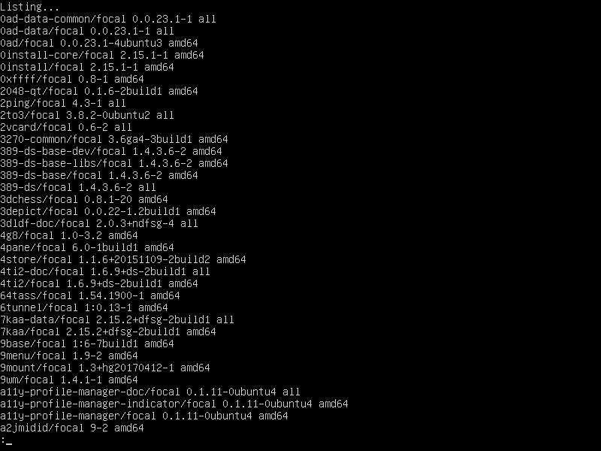Using the command apt list -installed | less you can scroll through a list of every package on the system.